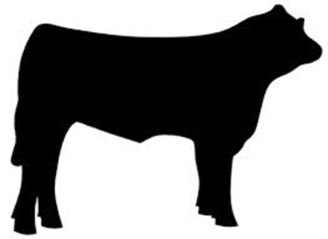
Market Cattle
Registrations Due: Friday, January 10, 2020 by 4:30pm
Weigh-in/Tagging: Sunday, January 19, 2020 12-2:00pm (Make-up Date: Sunday, January 26, 2020 12-2:00pm)
Weigh-in/Tagging: Sunday, January 20, 2019 12-2:00pm

December 20, 2019

To: Potential Shelby County Junior Fair Market Cattle Exhibitors
Re: Market Cattle Registration Procedures, Dates and More

This packet contains information regarding market cattle (steer and market heifer) registration procedures, rules, and dates for the 2020 Shelby County Junior Fair and related sale. If you know of new 4-H or FFA members who are planning to exhibit market cattle, please pass along these procedures and dates. Additionally, information regarding registering market cattle for exhibition at the 2020 Ohio State Fair is enclosed.
Important Dates
- All market cattle (beef and dairy steers) must be under the care of the exhibitor by Tuesday, January 1, 2020.
- Cattle registrations (enclosed) are to be submitted to the Shelby County Extension office no later than Friday, January 10, 2020 at 4:30 p.m.
- Cattle weigh-ins and tagging are scheduled for Sunday, January 19, 2020 from 12 to 2 p.m. In the event of inclement weather, the make-up weigh-in and tagging date will be Sunday, January 26, 2020.
- In addition to registrations, weigh-in and tagging, ALL market exhibitors MUST attend Quality Assurance or prove their knowledge by “testing out.” Quality Assurance. Please visit http://go.osu.edu/shelbyQA for details about Quality Assurance.
Registration
- All market cattle registration cards (enclosed) must be sent or dropped off to the Shelby Co. Extension Office (810 Fair Road, Sidney, Ohio 45365) by 4:30 p.m. on Friday, January 10, 2020. If the cattle are not entered by January 10th, exhibitors will not be permitted to show or sell market cattle at the 2020 Shelby County Junior Fair.
- Complete the enclosed card with appropriate information. Note: EACH exhibitor in the family must fill out one of these cards. Make sure to clearly indicate the number of market cattle to be tagged by using one line per animal. ***Do NOT list feeder calves on this card. Feeder calves must be born after January 1 and do not get weighed-in, tagged, or vaccinated in January.***
- This is NEITHER a 4-H enrollment card NOR a fair entry card, but rather a market cattle registration form. 4-H members will need to formally enroll through their 4-H clubs and projects by April 1, 2020. FFA members need to be actively enrolled in their school chapters. Additionally, all exhibitors will still need to submit a Shelby Co. Junior Fair entry form by June 1, 2020.
Weigh-In, Tagging and Sale
- Identification and sale order numbers will be drawn on Sunday, January 19, 2020.
- Weigh-in will be Sunday, January 19, 2020 from 12:00-2:00 p.m. at the Shelby County Fairgrounds.
- In addition to being weighed, all market cattle will be identified with an ear tag. Begin making arrangements to transport your market cattle to weigh-in now. If there is a problem with transporting market cattle, please call your 4-H or FFA Advisor. If arrangements still cannot be made, please contact a member of the Livestock Sale market cattle sub-committee (information below). While volunteers will help in any way they can, it is ultimately the responsibility of exhibitors to get their market cattle to the fairgrounds on Sunday, January 19th for weighing and tagging.
- Every animal to be tagged MUST have a halter and be halter broken. The Shelby Co. Livestock Sale Committee reserves the right to refuse weigh-in of any animal WITHOUT a halter.
- Market cattle must be dehorned by weigh-in. The Shelby County Livestock Sale Committee reserves the right to deny weigh-in of market cattle if not dehorned.
- Bull calves will NOT be weighed or tagged. All males should be properly castrated before weigh- in. The Shelby County Livestock Sale Committee reserves the right to deny weigh-in of male cattle if not castrated.
- We will NOT be weighing/tagging cattle for the Ohio State Beef Performance and Carcass Quality Contest. Other arrangements will need to be made for this, either at a neighboring Counties’ weigh-in or at an earlier date on certified scales
- If you have questions specific to weighing, tagging and sale, please call one of the following Livestock Sale market cattle sub-committee members:
  - Beef Cattle Chair: Chad Huelskamp 937-538-0752
  - Paul Monnier 937-606-0941
  - Mike York
  - Cathy Platfoot

DUNF Forms
- Completed Drug Use Notification Forms (DUNF) are required for each animal shown at the Shelby County Junior Fair. These may be obtained from the Extension Office or from advisors in early summer and must be turned in at the Shelby County Junior Fair during check-in/weigh-in. Blank forms will NOT be mailed to exhibitors.
- ALL animals are to be free and clear of any drugs upon checking in at the 2020 Shelby County Junior Fair.

Ohio State Fair
- Interested in showing at the 2020 Ohio State Fair? Please thoroughly read the enclosed paper! EID and DNA hair samples are required. A limited number of identification kits for the Ohio State Fair are available at the Shelby Co. Extension office. Please call ahead to reserve one.
- Members registering through 4-H will need 4-H Educator’s signature and those registering through FFA will need their FFA Advisor’s signature.
- Entries are due in the Ohio State Fair office by Wednesday, January 15, 2020.
If you have any questions, please contact the Shelby Co. Extension Office at 937-498-7239 or email me at Dietrich.145@osu.edu .
Sincerely,
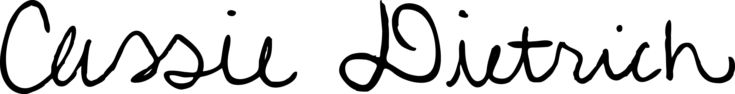

Cassie Dietrich
Extension Educator, 4-H Youth Development
dietrich.145@osu.edu

